Web Design Project Report





|  |  |
| --- | --- |
| Project Team | |
| Student No. | Student Names |
| X19139306 | Rory Cleary |
| X19175108 | Geneci Da Cruz Ui Fhátharta |
| X19176414 | Katarzyna Jablonska Casserly |

**Higher Diploma in Science in Computing**

**Cakes & Treats by Daniella**

**\*\* Insert deployed website URL Here \*\***

Contents

1 Project Overview 4

1.1 Our Client 4

1.2 Project Motivation 4

1.3 Project Goals 5

1.3.1 Major Goal 5

1.3.2 Specifics Goal 5

2 Section 1: Design 5

2.1 Research / Investigation 5

2.1.1 Company 1 5

2.1.2 Company 2 5

2.1.3 Company 3 6

2.2 Client Requirements 6

2.2.1 Functional Requirements 6

2.2.2 Non-functional requirements 6

2.3 Challenges 7

2.3.1 Expected Challenges 7

2.3.2 Unexpected Challenges 7

2.4 User Case 8

2.4.1 Use Case Diagram 8

2.4.2 Use Case Scenario 8

2.5 Technical Approach 9

2.6 Sitemap and Wireframe 9

2.6.1 Sitemap 9

2.6.2 Wireframe 10

3 Section 2: Development 11

3.1 Prototype 11

3.2 Decision on codes: 11

3.2.1 HTML 11

3.2.2 CSS 11

3.2.3 JavaScript 11

3.2.4 Colour Scheme 11

3.3 Validation and Errors 12

4 Section 3: Deployment 12

4.1 Choosing the hosting company 12

4.2 Cakes and Treats Live 12

5 Section 4: User Testing 12

6 Section 5: Project Team 12

7 Section 6: Conclusion 13

7.1 Aims 13

7.2 Lessons Outcomes 13

7.3 Skills Gained 14

7.4 Conclusion: Still to improve 14

8 Section 6: References 15

# Project Overview

This project is the result of one semester studies of the subject Web Design. We were requested to plan, design, develop, test and deploy a website at our own choice.

We choose to work with a client who wanted to have a website to show the cakes and treats she design.

As a group we accepted the challenge and worked hard in order to deliver a final product that would represent the groups' ability to work together and also to showcase all knowledge and skills we have acquired as a result of subject taken during this semester.

Several meetings were held in order to understand the meaning and level of services to be delivered at the end of the project. A set of rules were defined in order to direct the project. Major and specific goals were demarcated.

As a group we set five clear interim deliverables:

Deliverable One: Find a client and define on the website type – 11/10/2019

Deliverable Two: Gather all requirements and decide on website wireframe as well to have a prototype in place based on user case. – 25/10/2019

Deliverable Three: Develop and Test the website. – 22/11/2019

Deliverable Four: Deploy the Website. – 02/12/2019

Derivable Five: Submit the project. – 05/12/2019

## Our Client

Our client is a passionate cake maker Daniella (surname) who want to have a website to show up all beautiful and amazing cakes she design and bake. Daniella has a variety of products and now want to engage on vegan products to attract audience of this community.

## Project Motivation

When our group decided to go with Daniella website project the main motivation was that she wanted a simple website and because we are new to the website exposure we felt this is an opportunity to demonstrate that we can build this.

## Project Goals

As this is part of our learning outcome for a college subject, our main objective is to demonstrate that we have learned regarding HTML, CSS, JavaScript and the design process itself.

### Major Goal

Our major goal is to provide a functional website where our client can show her product and get request thought her email box via a web form.

### Specifics Goal

* To work well as a group and divide tasks evenly;
* To set out reachable deadlines for the necessary projects to be completed;
* To list the requirements needed to design the system;
* To fulfil the client’s needs by being able to provide them with a working website at the end of the project;
* To plan and design the website.
* To develop, test and deploy it

# Section 1: Design

## Research / Investigation

**\*\* NOTE:** You should look at a **minimum of 3 competitors**, giving details of which companies you looked at.

### Company 1

### Company 2

### Company 3

## Client Requirements

* The website should be compatible with all browsers and viewable on most technologies, for example desktops, laptops and mobile devices.
* Making changes to the website should be user friendly and easy to complete.
* The website should be easy for the user to use with easy navigation through the pages and consistent design and page layouts.
* A photo gallery or slide show of photos for her previous designed products.
* The website will be live for twenty four hours a day, seven days a week and will be free of charge for users to use.

### Functional Requirements

* Home page to contain links to social media pages for the organisation, for example Facebook and Twitter.
* Home page with picture.
* An easy to use website.
* An easy to use menu bar.
* An about us page which contains information about Daniella.
* A contact page with a form where visitors can request a cake and also provide Daniella with feedback.

### Non-functional requirements

* The website should be compatible with all browsers and viewable on most technologies, for example desktops, laptops and mobile devices.
* The website needs to have a fast response time and processing time for example in accessing the contact us form.
* Content from the Contact Us form should be directed to user provided email.

## Challenges

### Expected Challenges

The topics studied in the Web Design module were learnt key skills that could be brought forward into this project. Learning how to mix/match colours and learning basics in HTML, CSS and JavaScript were highly useful. Those skills and the group life experience are to help us with any challenge the project presents.

#### Coding

The skills involved in coding were a major challenge for two group members throughout the project. We planned to divide tasks and project part in order to all have contribution and whoever knew more to help to raise the technical skill of all members.

#### Interpersonal

Interpersonal skills also had to be developed. These skills could only be truly developed from experience. As an online group we met frequently via Skype and also on our WhatsApp group, with work being delegated to each other. We also had to meet online with our client to outline our requirements and ensuring everyone was happy with the agreements in place.

### Unexpected Challenges

#### Hosting

One of the main challenges we faced was the purchase of the hosting, at first we thought it was going to be expensive. We discussed hosting approach at our third meeting and then decide to leave it to conclude when the website was read. A member of the group offered to research possibilities and found a very good deal for us.

## User Case

### Use Case Diagram

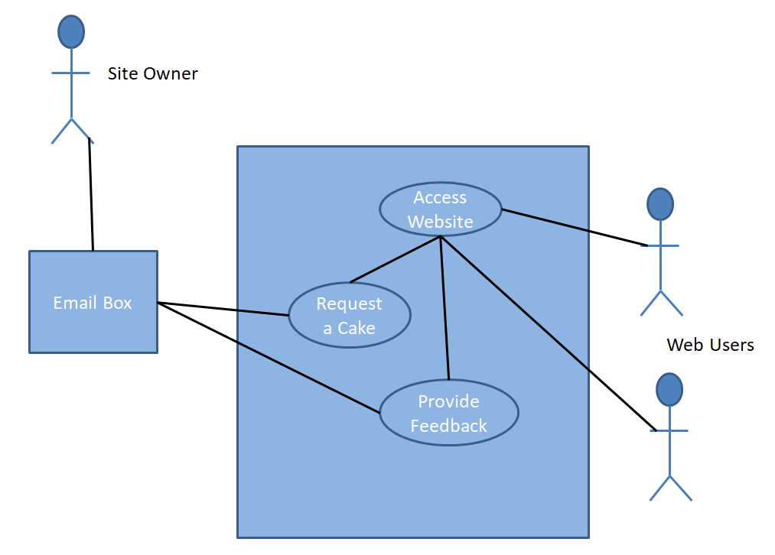

### Use Case Scenario

We tried to use user case scenario based on Behaviour Driven Development (BDD) notations. For that we developed two scenarios to guide us during the development.

#### Scenario 1:

* Given: User 1 access Cakes & Treats website
* When: User 1 fills up a form requesting a birthday cake
* Then: Daniella receive an email about request and User 1 contact details

#### Scenario 1:

* Given: User 2 access Cakes & Treats website
* When: User 2 fills up form providing feedback
* Then: Daniella receives another email with User 2 details.

#### Scenario 1:

* Given: Daniella access Cake & Treats backend
* When: Daniella opens any page files
* Then: Daniella is able to make change to the website.

## Technical Approach

Our group decided to follow a methodology where we would build according to what we were learning, consulting with client and testing. This will help us to avoid mistakes to correct at the very end of the project.

The methodology is not 100% Agile because of the nature of the project but we try to use as much as we can this approach as we believe is the best when the subject is building web based system.

We also decided to use GitHub so we all could code at same time and be aware of changes made to the whole project.

## Sitemap and Wireframe

### Sitemap

The site Map consists of a home page that links to all others 5 pages.

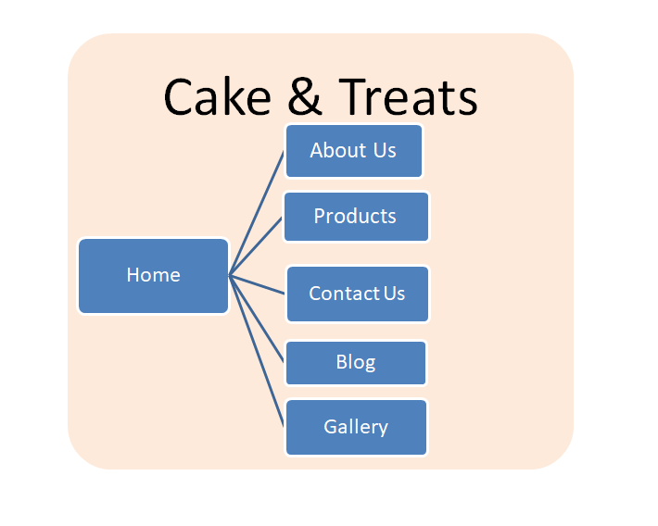

### Wireframe

#### Chosen Wireframe

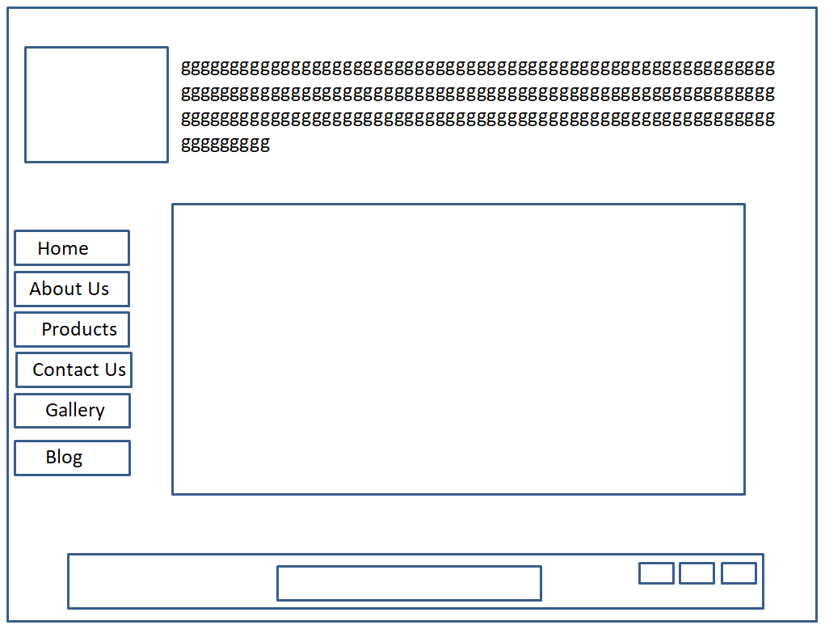

#### Suggested Wireframe

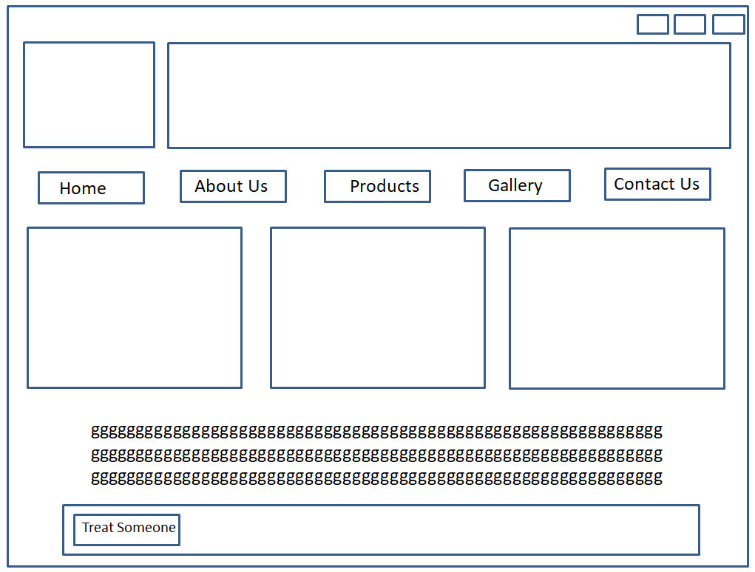

# Section 2: Development

## Prototype

We created a version of the site and tested the function such as, page navigation. Once client and we were happy with the process we decided to go ahead and built the current site.

For us prototype the website was more to see the flow of the pages as this is a simple website to show the range of client product.

## Decision on codes:

### HTML

** This section should outline how you went about developing your webpage, i.e. HTML, CSS, JavaScript. This should include information on requirements and standards implementation, code development and technical details, such as errors or development issues and how you fixed these.

**Please note:** Make sure to include an explanation in this report (**as well as** comments in the HTML files) of any & all code that was taken from the web, or you will **not** receive marks for this third-party code. **

### CSS

** This section should outline how you went about developing your webpage, i.e. HTML, CSS, JavaScript. This should include information on requirements and standards implementation, code development and technical details, such as errors or development issues and how you fixed these.

**Please note:** Make sure to include an explanation in this report (**as well as** comments in the HTML files) of any & all code that was taken from the web, or you will **not** receive marks for this third-party code. **

### JavaScript

** This section should outline how you went about developing your webpage, i.e. HTML, CSS, JavaScript. This should include information on requirements and standards implementation, code development and technical details, such as errors or development issues and how you fixed these.

**Please note:** Make sure to include an explanation in this report (**as well as** comments in the HTML files) of any & all code that was taken from the web, or you will **not** receive marks for this third-party code. **

### Colour Scheme

For colour scheme of the website we researched on the web common colours for cakes and treats website. Then we created a questionnaire with the most used 5 scheme and provided to user to choose from the questionnaire or to suggest any other scheme. The chosen colour scheme is recorded as below.

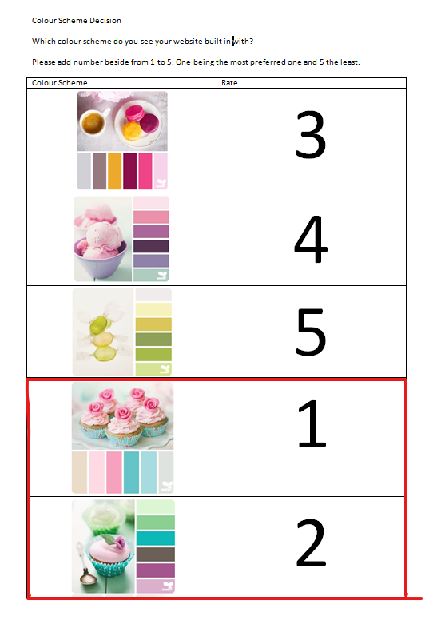

## Validation and Errors

** This section should look at validation of the website (HTML & CSS), were you able to validate the website, were there any errors and if so, how did you go about fixing them.

**Please make sure to include a screenshot(s) of your validation reports here \*\***

# Section 3: Deployment

## Choosing the hosting company

** This section should include information on your choice of deployment, as well as your websites URL and a screenshot of the live site **

## Cakes and Treats Live

Cakes & Treat image from live when available **

# Section 4: User Testing

** This section should include information on any user testing carried out on your website, i.e. how many people you tested it on, what tasks you asked them to preform, the results of testing, if you implemented any user suggestions, etc. **

# Section 5: Project Team

** How did the project team break up the tasks required?

Who did what tasks? Did everyone evenly participate?

Were there any team issues? How were these issues resolved? Etc. **

**Please note:** You will each be asked to individually peer review your team mates also

# Section 6: Conclusion

The definition of achievements by the team could be seen from the Project success Criteria that has been identified in the early planning stage of the project, this includes:

The team analysed that:

*The success of this project will be determined by some criteria which includes;*

* That the project is able to meet all requirements as specified in the requirement section.
* That it meets the purpose, objective and satisfaction of Client and Users.
* That all deadline are targets are meet in due times stipulated by the project document and by our own team.
* That every deliverables in the life of the project meets everything to a high standard.
* There is the successful deployment of the website.
* And for the group, that all learning curves are achieved at the end of the project lifecycle.

Therefore the project achievement is been considered from the light of accomplishing the above statement under the following headings:

## Aims

* The team was able to meet the aims by delivering a fully functional website with a form for user to contact our client.
* Was able to satisfy our Client and her Users by meeting all the requirements that has been set out.

## Lessons Outcomes

The learning outcomes gained by the team members were great, we all have benefitted a lot of first hand experiences from going ahead with this project, all learning curves was achieved, from low from the early weeks and increases as the weeks went by with learning of new applications and researches from different sources.

## Skills Gained

Some of the skills gained by the members of the team include:

* Planning and Coordination skill: We have been able to acquire the skill of planning, as well as coordinating from the beginning of the lifecycle of the project till the end;
* Team work collaboration: We were able to work together on the project, using social networks such as Skype, WhatsApp, GitHub and emails to improve effective communication among members;
* Problem Solving Skills: The team learned how to identify and solve problems step by step;

## Conclusion: Still to improve

In General we are very happy with the result achieved as we were able to deliver all requirements for the website in both level: from the project point of view and also from the client perspective.

Our team had a clear vision of work with we were comfortable with due to the scope and time of the project. Saying that, we as team, believe that the website could have some improvement to better serve the client needs in the future. For example our client could ask for a database to be designed so that she could better administrate orders and feedbacks from users.

# Section 6: References

FormGet. 2015. HTML CSS. [ONLINE] Available at: <http://www.formget.com/category/html-css/>.[Accessed 25 October 19].